Instantaneous Velocity - ______________
How do we find the velocity at 6 seconds?
d (cm)
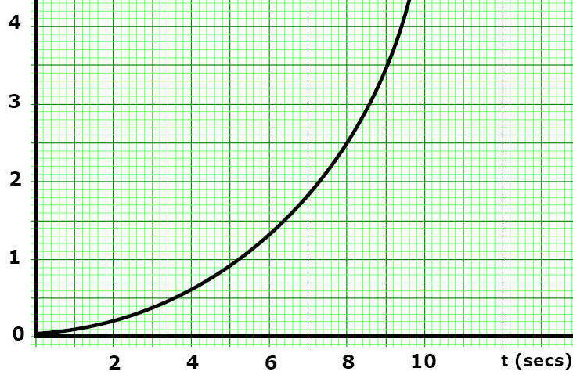
Step 1 - Draw a tangent line at the time you want to find the velocity
d (cm)
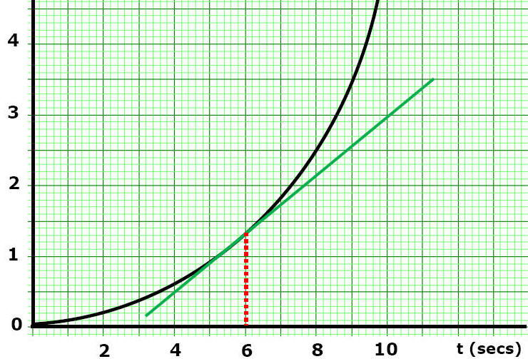

Step 2 - Find the SLOPE ________________________________

B. Interpreting Motion Diagrams
Acceleration Review

Acceleration - ________________________________________________

Which data shows uniform ( ) acceleration? Why?
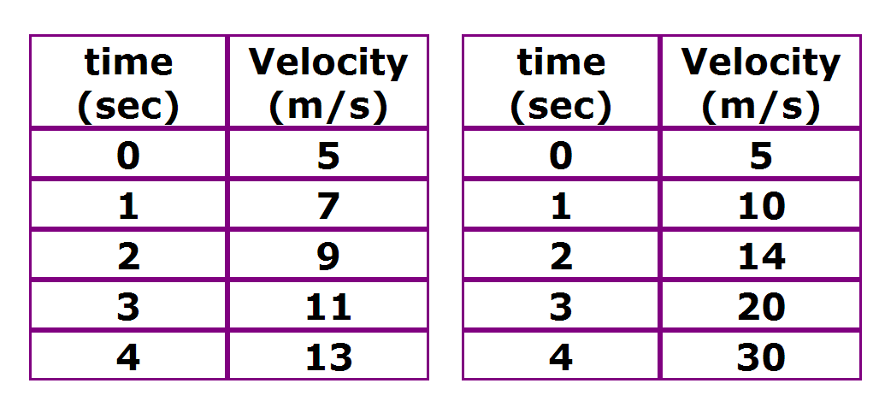

Ex) Describe the motion that produced this plot
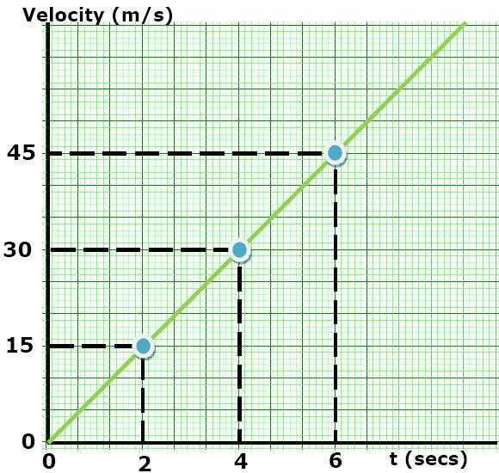

Ex) Describe the motion that produced this plot
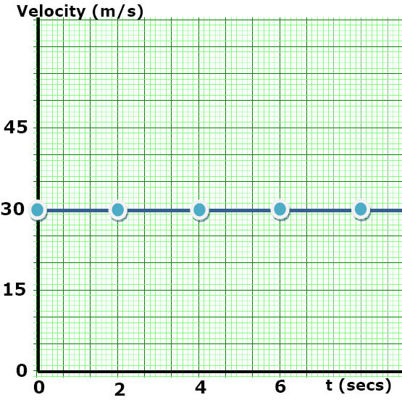

Ex) Largest acceleration?
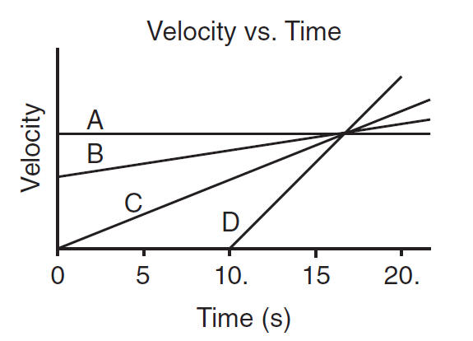

Ex 4) Describe the acceleration
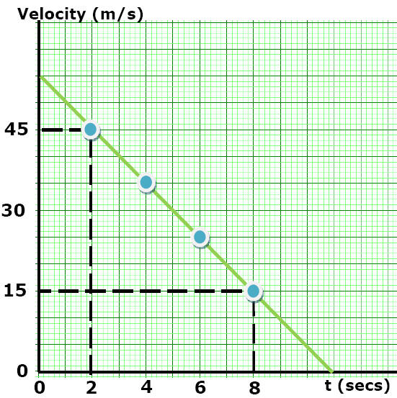
Ex 5)
V (m/s)
d (cm)

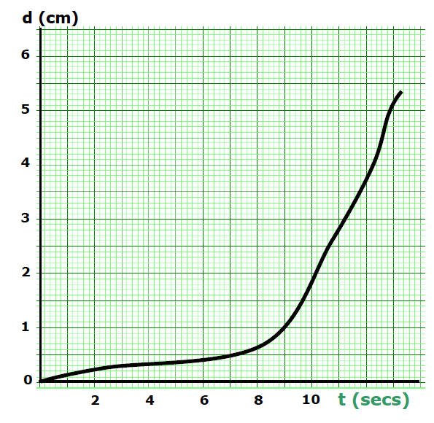
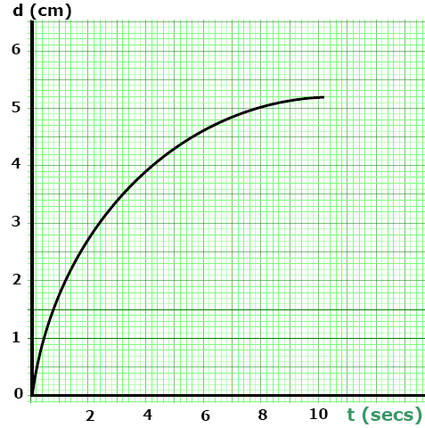
d (cm)

