Ex 2) Conservation of Energy in a Rollercoaster
The mass of the rollercoaster is 3.0 kg Gravitational PE Equation = ________________

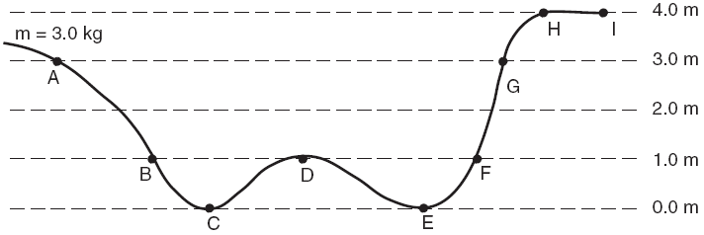

 | PE | KE
A
B
C
D
E
F
G
H
I

