When physicists study motion they study displacement not distance.

C. Displacement - __________________________________________

1) Examples
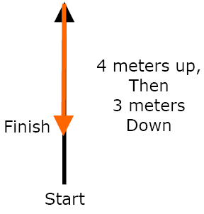

Distance? __________________

Displacement? _____________________

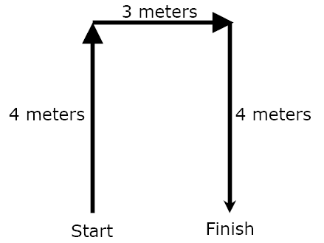

Distance? __________________

Displacement? _____________________

2) Displacement always has ... _____________________ and _______________

a) Examples

b) Positive and Negative Signs also show ________________

+ Usually _______________________ - Usually ____________________________

c) Symbol for displacement:

