Unit I - Mechanics - Study of the relationship between _________ and
________________

I. Kinematics - Mathematical methods of ____________ and predicting _______

Describe motion by using:

- ___________________

Average Speed of ________________________ can also be written ...

Could mean travelled ____________________

OR ....

Avg. Speed -
- Units:

Ex 1) An object travels 5 meters in 2 seconds.
Find its speed.

Ex 2) An object moves at a rate of 3 m/s for 1.5 seconds.
How far did the object move?

Motion Map

Ex 3) An object moves at rate of 4 m/s over a distance of 10 meters.
How long did it take to travel that distance? t = ?

Motion Map

B) Motion Plots (A. K. A. Motion Diagrams)
Position Vs Time Plot - Movement in a Straight line
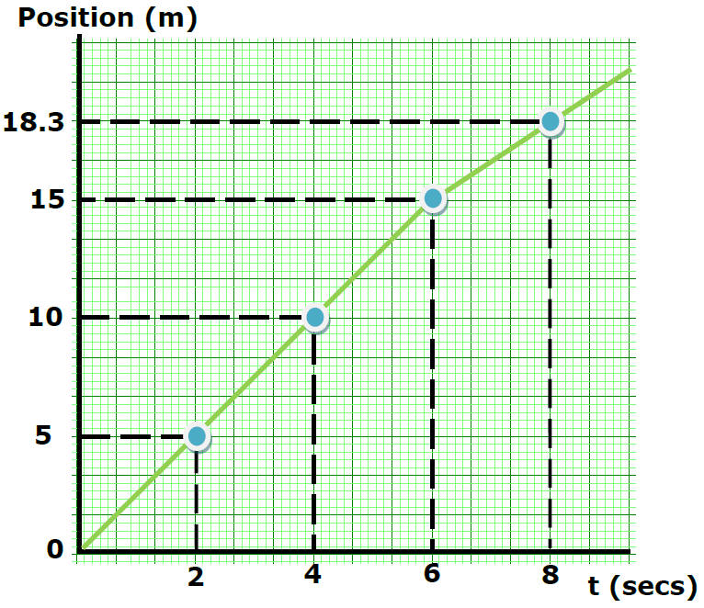
Position (m) | Time (sec)
 | 0
 | 2
 | 4
 | 6
 | 8

Motion Map

Speed from 0 to 2 seconds?

Speed =

Speed from 2 to 4 seconds?

Speed from 4 to 6 seconds?
Speed =

Does the object travel faster or slower from 6 to 8 seconds?

Compare speed from 6 to 8 sec with speed from 8 to 9 sec

What kind of motion produced this plot?
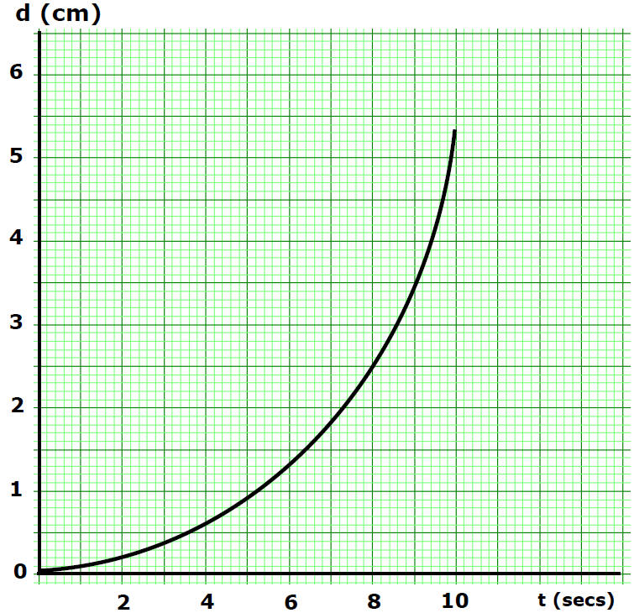

Motion Map

