II. Motion Diagrams - plots of motion data - Detailed, visual way of describing motion
Describe the velocity for the next 2 plots.
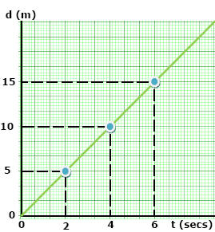

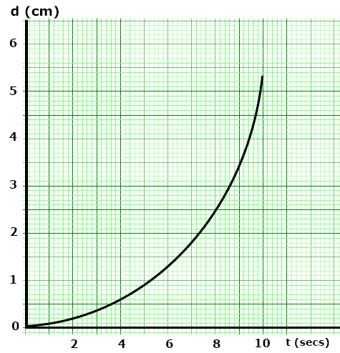

A. Displacement vs. Time Plot
(d) Displacement (m)
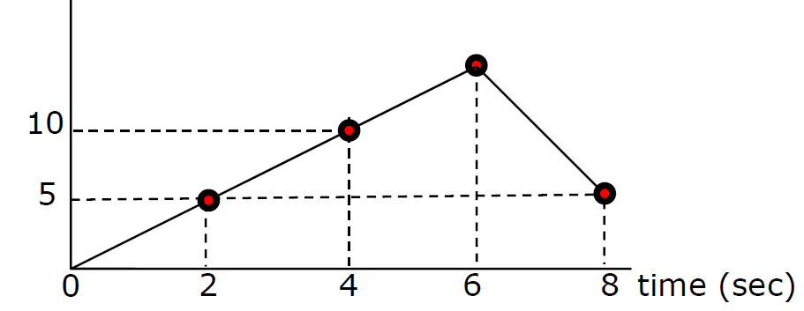
Calculate the Velocity from 2 to 4 sec
V =

Calculate the Velocity from 2 to 4 sec

Calculate the Velocity from 4 to 6 sec

What is happening from 6 to 8 seconds?
Motion Map for Entire motion

Describe the various motions shown in this plot
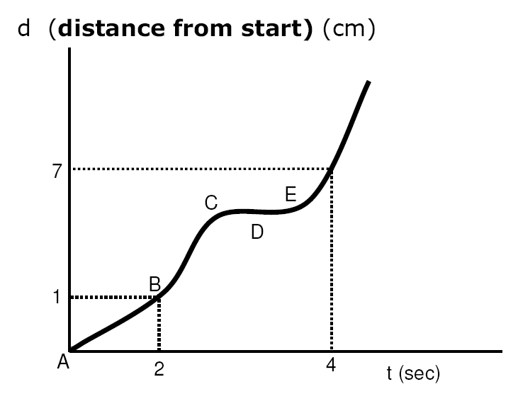
A to B?

B to C?

D?

D to E ?

