C. Velocity - ___________________________________
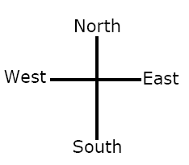
Ex) Joe drove 13 meters North East in 2.0 seconds
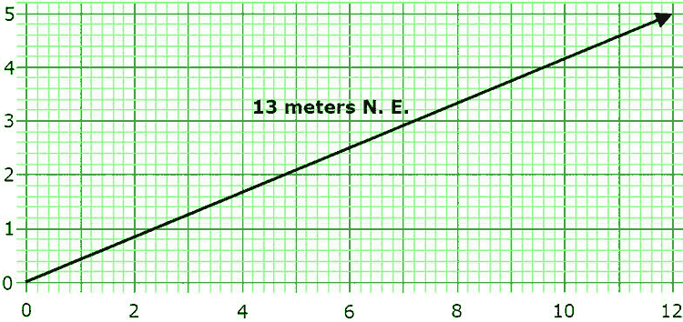
What was Joes ...
Northeast displacement? Displacement east? Displacement north?

We can say that Joe has _________ velocities

